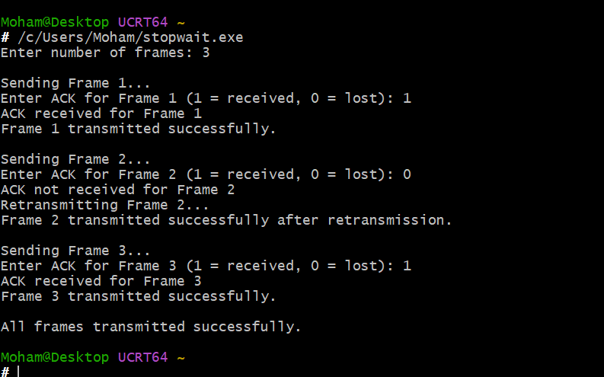
implemented the Stop-and-Wait protocol using C. The sender sends one frame and waits for an acknowledgement. If the acknowledgement is not received, the frame is retransmitted. After receiving the ACK, the sender proceeds to the next frame

